***Lab 3***

***Deployment Set***

* nano mydeploy.yml

kind: Deployment

apiVersion: apps/v1

metadata:

name: mydeployments

spec:

replicas: 2

selector:

matchLabels:

name: deployment

template:

metadata:

name: testpod

labels:

name: deployment

spec:

containers:

- name: c00

image: ubuntu

command: ["/bin/bash", "-c", "while true; do echo GOOD MORNING QASIM; sleep 5; done"]

* kubectl apply -f mydeploy.yml
* kubectl get deploy

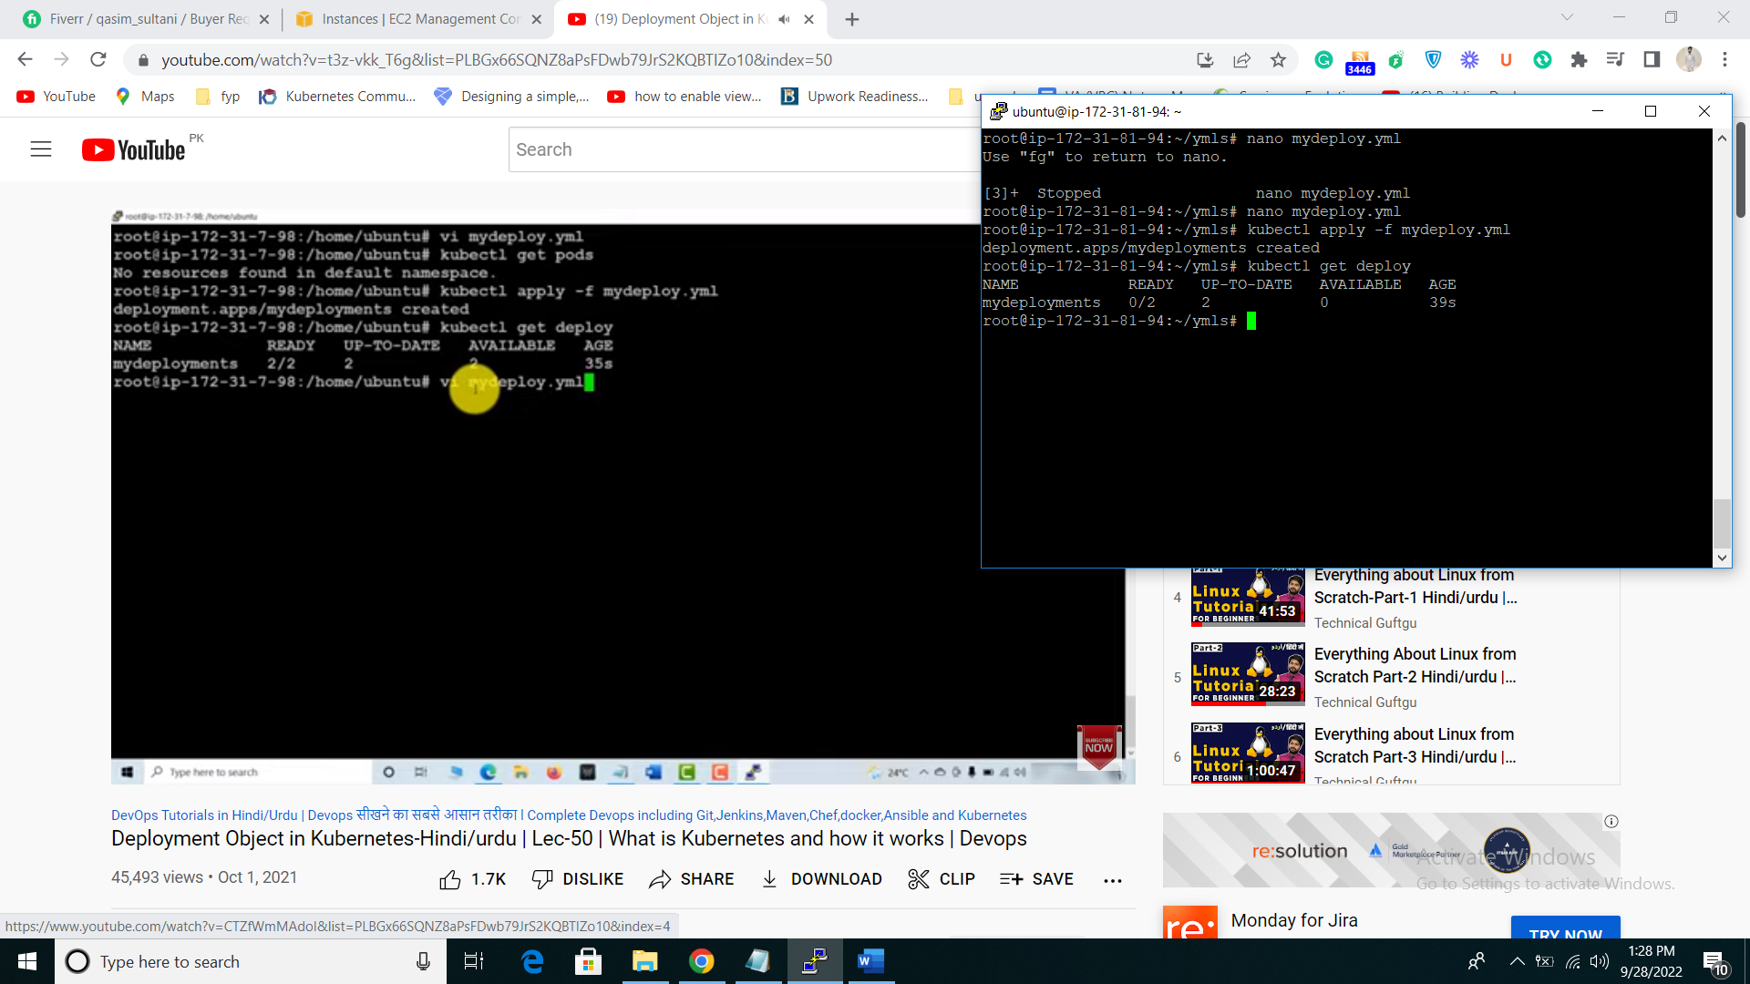

* kubectl describe deploy mydeploy //to check description of deployment object
* kubectl get rs
* kubectl get pods

//delete the pods and check you still get 2 pods because we set 2 pods available on rs

* Kubectl scale –replicas=6 deploy mydeploy
* kubectl logs -f mydeployments-b84d46c8b-7kfhq //to check message in pods

//now if you update your application and you want to deploy it you just have to change the last rs file

And there image this will stop the last rs set and create new rs

**ROLL OUT REPLICA SET**

* kubectl rollout status deployment mydeploy //one step rollout back suppose your deploy 6 times and it’s came to 5 time deployment version
* kubectl rollout histroy deployment mydeploy // how many times we do changes “mydeploy is my ym file name”
* kubectl rollout undo deploy/mydeploy // rollout and last version shifted